- ALU :- Output

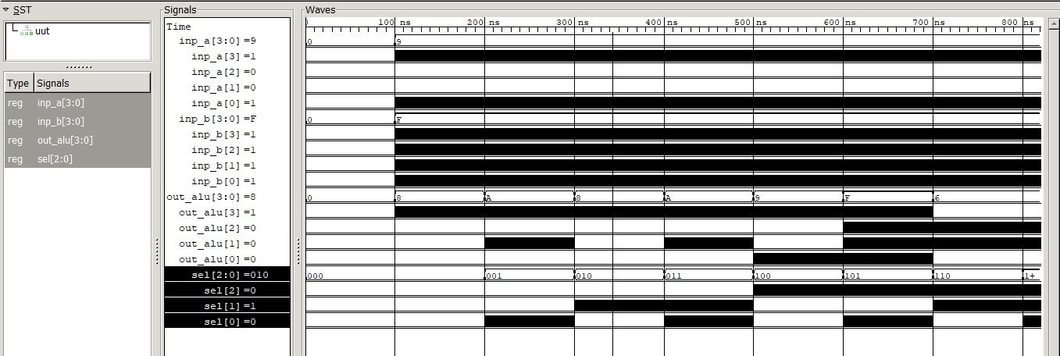

Conclusion :-
- Arithmetic Logic Unit are implemented using VHDL.

